Overview

Objective
To ensure the MCP (Multi Criteria Prioritization) Template is used in a consistent manner.
Contents
Overview 1
Objective 1
Roles, Responsibility and Authority 2
Background 2
Procedure Detail 3
MCP Template Overview 3
The Summary Tab 3
The Detail Sheet Tab 3
Step 1: General and Cost Information 4
Step 2: Benefit Analysis 5
Step 3: Evaluate Uptakes and Alignment 8
Step 4: Rank 9
Step 5: Projected Cash Flow (optional) 10
Step 6 Residual Risks 11
The Benefit Chart 12
The Project Distribution Chart 13
The Project Distribution Chart per Service 14
The Cumulative Capex Chart 15
The Residual Risk Rating Matrix 16
References and/or Resources 17
Residual Risk Rating Matrix 18

Roles, Responsibility and Authority
Role | Responsibility | Authority
Investment Planner | To follow the procedures outlined.
Asset Manager | Ensure that the MCP rater of Business Cases follows the procedures outlined.

Background
This MCP Template was developed to evaluate the Benefits of a Business Case. The resulting Benefit Score is used in the Cost Benefit Ratio which is used to prioritize projects. The Benefit Evaluation Process provides an objective means to score Business Cases consistent with the priorities set up by the City's Senior Leadership Team.
The following equation describes how Benefit Scores are calculated:
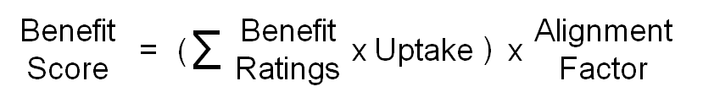
Strategic priorities are combined with service objectives to establish a list of evaluation criteria. Each criteria is weighted to reflect its importance in the planning and decision-making process. Descriptions are developed to ensure that each criteria is interpreted and applied in a consistent manner. The City of Winnipeg’s current Prioritization Model uses 10 Evaluation Criteria, which have been established and weighted.
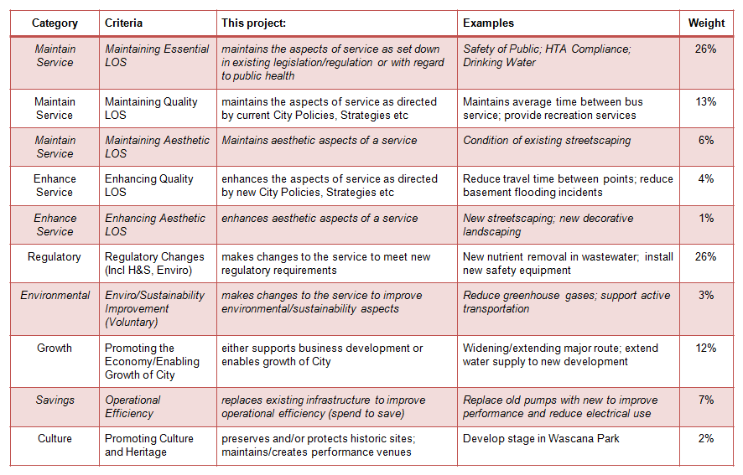

Procedure Detail

MCP Template Overview
This tool includes nine different tabs that are identified by four colors:
Tab | Purpose
White Quality Information | Contains the version and updates pertaining to the Template.
Green Summary | Contains specific information from the Detail worksheet (Detail Tab) that can be viewed, printed and used to develop an Investment Plan.
Blue Detail Sheet | The Detail worksheet is where all the data is entered in order to generate information for the other tabs.
Red tabs | - Benefit Chart  - Project Distribution Chart  - Proj Distrb Chart per Service  - Cumulative Capex  Contain specific graphs to illustrate the results of the Benefit Assessment.
Grey tabs | - Cumulative Cost Chart Data  - Example Cumulative Cost Data  Contains various pieces of data that are used in the calculations.

The Summary Tab
The Summary Worksheet provides a specific view of the information derived from the Detail worksheet.
No information needs to be added to this worksheet as the date is generated from the information that has been entered in the Detail Tab.
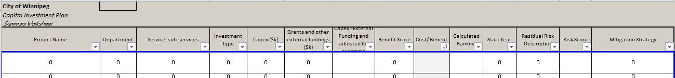

The Detail Sheet Tab
This section consists of 6 Steps in order to complete the Detail Sheet.
The following Steps describe the Detail Worksheet’s column items and the type of information required.

Step 1: General and Cost Information
This Step involves entering information under the “General” and “Cost” headings (grey-coloured columns) in the Detail Worksheet. The information to be entered in this section can be taken from the Project Business Case.
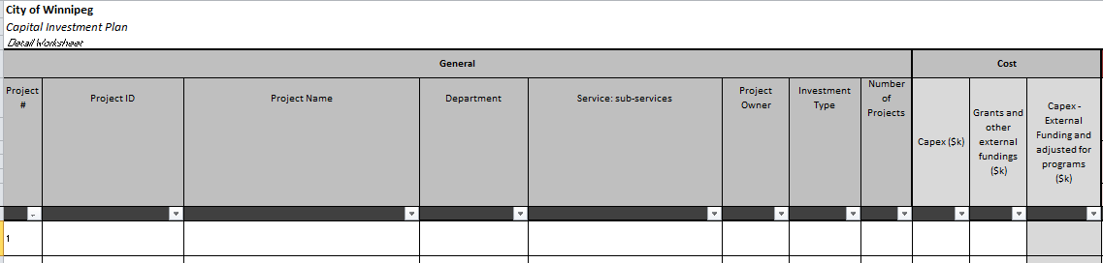
“General” and “Cost” Items | Explanation / Instruction
Project # | Enter the sequential number based on the initial data entry position.  It is used to sort the Projects if necessary.
Project ID | The Business Case Project ID.  This is a unique Identification Number for the Project.  The Project ID is found _____.
Project Name | Enter the Project Name as exactly on the Business Case.
Department | Select the Department from the drop down list.
Service - sub-service | The Sub-service Category from the Service View Budget.  Select the sub-service category from the drop down list.
Project Owner | Enter the name of the Project Sponsor or Project Manager.
Investment Type | Choose between the two types of investments from the drop-down list:  Project or Program
Number of Projects included in Program | Enter the number of Projects included in the Program.  For linear Asset Projects, it may be difficult to know the number of Projects included in the Program. In that case, estimate the number of Projects you will/could do for the investment amount requested.
Capex | Enter the Capital Expenditure in $K required to complete the Project.  For Programs, include one year of Capital Expenditure.
Grants and other external funding | Enter the value of any external funding that the investment will receive.
Capex - external funding, adjusted for programs | Automatically subtracts the external funding from the Capex value (if a Program), then divides the amount by the number of Projects within a Program.

Step 2: Benefit Analysis
This Step involves entering information under the “Benefits Analysis” heading (red-coloured columns) in the Detail Worksheet.
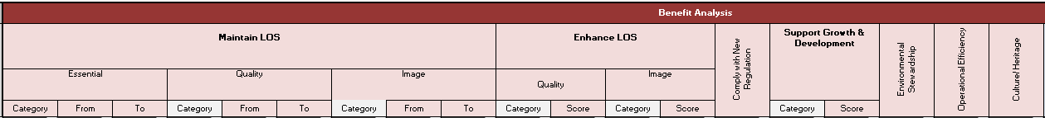
This Step requires the use of the “Benefit Evaluation Sheet” in the Benefit Evaluation Criteria Procedure to help assess each Benefit Criteria.
The Benefit Criteria descriptions in Benefit Evaluation Sheet will help identify the Type and extent of Benefits applicable to each Option being assessed for each Solution.
- For each Item, evaluate the proposed investment relative to each of the primary Benefit criteria. If merit, each investment can be evaluated and receive benefit points from each of the benefit criteria, benefit uptakes and alignment factors.
  - More than one Consequence category within the primary Benefit criteria could be applicable
For example, Maintain Essential LOS has 3 categories (Measures): (1) Legislative Compliance; (2) Health and Safety; and (3) Environmental consequence).
Use the Category in which the greatest rating is achieved within each criteria and use this selection in the “Category” column.
- If a Benefit Criterion is not applicable to the Project, leave the evaluation "blank" in the appropriate column.
All Benefits will not be applicable to each Project but hopefully each Solution has at least one applicable Benefit.
“Benefits Analysis” Items | Explanation / Instruction
Maintain LOS
Essential  (under Maintain LOS) | Rank how this Project maintains the aspects of service as dictated by existing legislation/regulation or with regard to public health.  A failure to comply would expose the Business Unit to serious consequences.  Complete the columns under Essential as follows:  - Category:  Select the applicable Consequence from the drop-down list.  - From:  Select one of the 25 Risk Exposures in terms of Consequence and Likelihood at the time before the Investment is made from the drop-down list.  - To:  Select the Consequence and Likelihood rating at the time after the Investment is made from the drop-down list.
Quality  (under Maintain LOS) | Rank how this Project maintains the aspects of service as directed by current City Policies and Strategies. This includes bringing an Asset up to current LOS or meeting existing Service Level Agreements (SLAs).  A failure (e.g. severe and recurring reliability problems) would affect the service provided to the customers but would not expose the Business Unit to the same level of Consequences as a failure with an Essential LOS.  Complete the columns under Quality as follows:  - Category:  Select the applicable Consequence from the drop-down list.  - From:  Select one of the 25 Risk Exposures in terms of Consequence and Likelihood at the time before the Investment is made from the drop-down list.  - To:  Select the Consequence and Likelihood rating at the time after the Investment is made from the drop-down list.
Image  (under Maintain LOS) | Rank how this Project maintains the aesthetic aspects of a service and/or public criticism.  Complete the columns under Image as follows:  - Category:  Select the applicable Consequence from the drop-down list.  - From:  Select one of the 25 Risk Exposures in terms of Consequence and Likelihood at the time before the Investment is made from the drop-down list.  - To:  Select the Consequence and Likelihood rating at the time after the Investment is made from the drop-down list.
Enhance LOS
Quality  (under Enhance LOS) | Rank how this Project enhances or increases an existing Level of Service.  Complete the columns under Quality as follows:  - Category:  Select the Consequence from the drop-down list.  - Score:  Select one of the 5 ratings from the drop-down list.
Image  (under Enhance LOS) | Rank how this Project enhances or increases the aesthetic aspects of a service and/or public image.  Complete the columns under Image as follows:  - Category:  Select the Consequence from the drop-down list.  - Score:  Select one of the 5 ratings from the drop-down list.
Comply with New Legislation | Rank how this Project makes changes to the service to meet new regulatory requirements.  - Select one of the 5 ratings from the drop-down list.
Support Growth and Development | Rank in terms of Support Growth and Development how this Project either supports business development or enables growth of the City.  Complete columns under Support Growth and Development as follows:  - Category:  Select the Consequence from the drop-down list.  - Score:  Select one of the 5 ratings from the drop-down list.
Environmental Improvement | Rank how this Project contributes to the Business Unit’s Environmental Management Plan Objectives by making changes to the service to improve environmental/sustainability aspects.  - Select one of the 5 ratings from the drop-down list.
Operational Efficiency | Rank the net savings per year this Project will bring by replacing existing assets with improvements by this Project.  - Select one of the 5 ratings from the drop-down list.
Culture / Heritage | Rank how this Project contributes to the preservation and/or protection of historic sites or the maintenance/creation of performance venues.  - Select one of the 5 ratings from the drop-down list.

Step 3: Evaluate Uptakes and Alignment
Step 3 involves completing the columns that are blue-coloured but still under the Benefits Analysis heading.
These six columns can be divided into two categories:
- Benefit Uptakes (Coverage, Strategic Importance, Locational Criticality) are considerations that are proportional to an Asset’s userbase.
- Alignment Factors (Life-cycle Bonus, Coordination Bonus, Cost of Deferral Bonus) are planning and business considerations and are applied to a Solution if applicable.
Complete each column by selecting one of the 5 Ratings for each item from the drop-down lists.
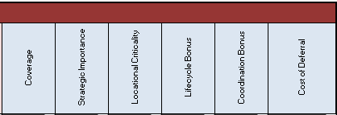
Benefit Analysis -Uptakes Items | Explanation / Instruction
Coverage | Rank who, where and the number of people that is impacted by the proposed solution.
Strategic Importance | Rank the importance of the Project to major strategic initiatives, often council driven.
Locational Criticality | Rank how the Project affects existing surrounding assets and the level of public exposure/criticism.

Benefit Analysis -Alignment Items | Explanation / Instruction
Life-cycle Bonus | Rank how the proposed Solution, in terms of providing the best Whole-Life Value, meets with the optimum Business Case.
Coordination Bonus | Rank how the proposed Solution allows for coordination with other Projects resulting in costs savings and efficiency for the City.
Cost of Deferral Bonus | Rank what additional costs will incur to the Project if the investment is delayed.

Benefit Score Summary
Data entered for each of the preceding columns are automatically calculated in the Benefits Score Summary section (green-coloured columns) of the Details Worksheet.
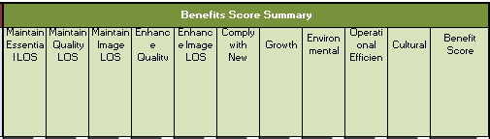

Step 4: Rank
Step 4 involves the review of the automatically-calculation of the columns under the Rank heading (olive-coloured columns) and allowing for adjustments to include external factors that have not been taken into account.
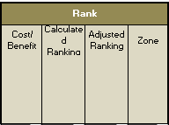
The items under the Rank column are explained as follows:
“Rank” Items | Explanation / Instruction
Cost Benefit | This Rank is automatically populated based on the data already entered.
Calculated Ranking | Calculations are automatically generated based on the Project’s Cost/Benefit Score.
Adjusted Ranking | This column allows the Investment Planner to adjust the Project Ranking.  Some Projects will indeed need to be moved for various reasons due to Coordination with other Projects, Grants, or Other Special Funding arrangements, Major events for the City (e.g. Canada Summer Games), or Other External Factors.  The data entered here reflects the External Factors that are not otherwise taken into account by the Project Prioritization Model into the ranking.
Zone | This Rank is automatically generated based on the Cost Benefit Ratio.  The data is shown as a graph in the “Project Distribution Chart” tab.

Step 5: Projected Cash Flow (optional)
This section can be used by the Investment Planner to develop their initial multiple-year Investment Plan that reconciles investment priorities with available yearly funding.
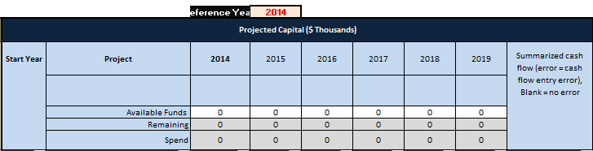
The items under the Projected Capital columns are explained as follows:
“Projected Capital” Items | Explanation / Instruction
Reference Year  (top row) | Enter the Budget year and this will automatically fill in the budget year and forecast years under the Projected Capital ($ Thousands) heading.
Projected Capital | This section allows the adjustment of budget dollars based on when the initial investment is required and how the dollars are allocated over the years.
Start Year | Allows the adjustment of the project to start from Year 1 to Year 6 of the investment cycle.
Project | The project name is automatically populated here to assist in the cash flowing of the projects.
Available Funds | This row is only used if the Investment Planner is using the MPC for a Single Funding Envelope. This is not used by all Departments.  Enter the amount of dollars available per year.
Remaining | An automatically generated figure showing the difference between “Available Capital” and the “Spend” amounts.
Spend | An automatically generated summary of the value of the entire column.
Summarized cash flow | Automatically adds the yearly allocation values to ensure the total value equals the total “Capex – external Funding” value.  If the value “error” appears, this indicates that an error was made entering yearly investment values.

Step 6 Residual Risks
This section is used to identify the "Residual Risk" of a specific Project being delayed due to the Prioritization Ranking Score.
If the Risk is too great, the Project should be considered in the budget year versus in a forecast year.
i.e. what is the risk of delaying the Project by one or more years?
Refer to the Residual Risk Matrix section to evaluate the Economic, Environmental, Social, Legislative, Health and Safety, and Operational risks.
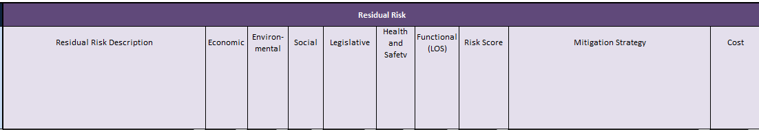
“Residual Risk”  Items | Explanation / Instruction
Residual Risk Description | Describe the Risk Event “of the Project being not completed in the budget year”
Economic | Assess the Risk Event to the Consequence and Likelihood Scale in the Residual Risk Rating Matrix. Select the Risk Exposure from the drop-down list.
Environmental
Social
Legislative
Health & Safety
Functional (LOS)
Risk Score | Automatically calculated based on the value entered.
Mitigation Strategy | For each of the Projects that are being delayed, a Mitigation Strategy shall be described for the Risk, and the associated cost to the project.  After evaluation, if a Risk is deemed unacceptable, the Project shall be moved back to start in Year 1 and the cash flow adjusted accordingly.
Cost | Estimate the cost of the Risk Mitigation Strategy that will be undertaken (actual dollars that will be spent) and the cost should the Risk Event occur (estimated dollars if the event were to occur).

MCP Charts (Graphs)
Note: In order to adjust the data in the graphs, the Investment Planner will need to know how to edit graphic data.
The four graphs (each in its own tab) are intended to show specific views of the data to support the Investment Planning decision-making. The graphs have been set-up for a data range which varies in each graph (with the exception of the Cumulative Capex Graph).
The Investment Planner can only edit the data range in each graph based on the Project population.

The Benefit Chart
The Benefit Chart displays the Projects in order of its Benefit Score.
The columns in the Detail Sheet Worksheet that contain the data for this graphic cannot be set to “Hide”.)
To adjust the data of the Benefit graph:
- In the Detail Sheet sort the Cost/Benefit column (under “Rank” section).
- Adjust the Data Range depending on Project population.
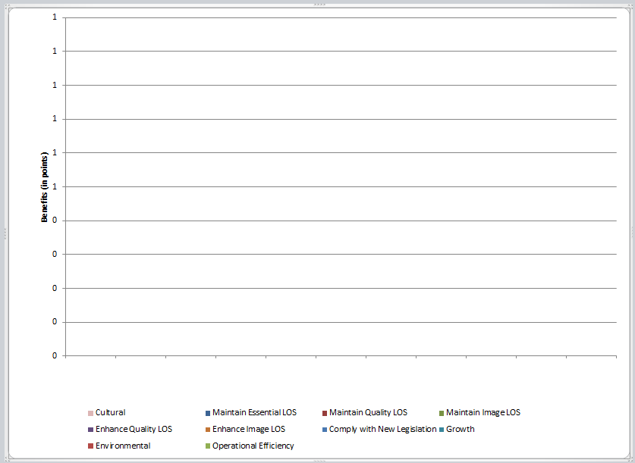

The Project Distribution Chart
The Project Distribution Graph displays each Project relative to their Cost/Benefit score.
Six Cost-Benefit "Zones" have been established to help visualized how projects compare to each other:
Zone 1 includes all the projects with a cost-benefit ratio below 0.1, meaning that these projects provide a high Benefit for a low cost and are the "easy wins" projects (project that should proceed in priority);
Zone 6 is the opposite of Zone 1 and includes all the projects with a cost benefit ratio above 10, meaning that these projects have a high cost for a low Benefit and are more "difficult to justify".
When funding is constrained and cannot accommodate all projects, Projects in higher Zones (e.g. Zone 6, 5, 4) should be taken out of the Capital Investment Plan in priority unless significant residual risk is identified.
To adjust the data in the Project Distribution Graph:
- Adjust the data range based on Project population.
Do not edit the “Cost Benefit series” entries in the Detail Sheet.
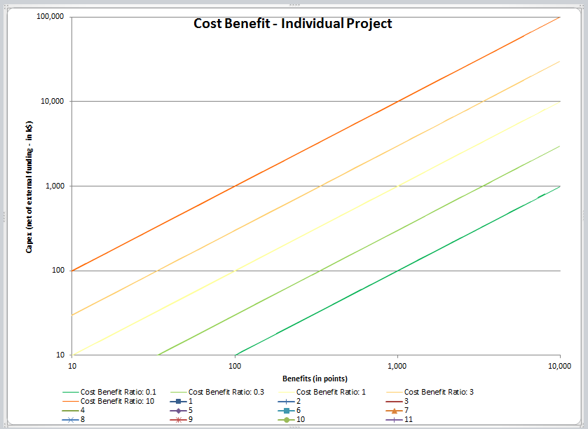

The Project Distribution Chart per Service
The Project Distribution Chart per Service displays the Cost Benefit Score for the projects grouped by the Service view category. This chart has the same concept as the Project Distribution chart except that the Projects are grouped based on their “Service view” category.
To adjust the data of the graph:
- In the Detail Sheet, sort the Service: sub-service column (under the “General” section).
- Adjust the data range based on project population.
This will include editing existing data points and adding new data points:
Note: Do not edit the “Cost Benefit series” entries.
  - In the Detail Sheet, select “Series name” from the Sub-service column
  - Select the “x data range”; “Benefit Score” column that corresponds to the range that the sub-service category is applicable
  - Select the “y data range”: “Capex - external funding, adjusted for programs” column that corresponds to the range that the sub-service category is applicable
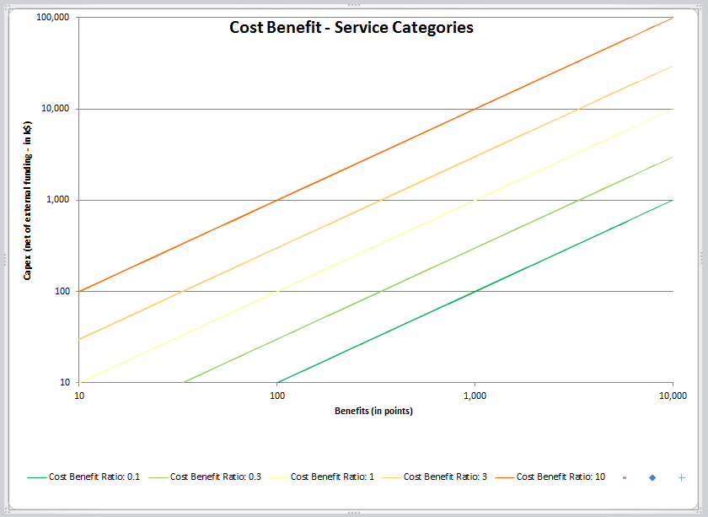

The Cumulative Capex Chart
The Cumulative Capex displays the cumulative sum of each Project sorted based on the Cost/Benefit score.
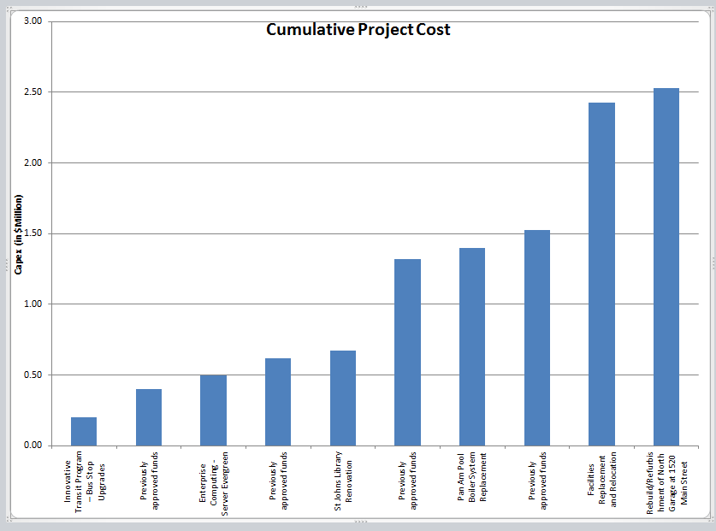
The Cumulative Capex Chart
To adjust the data of the Cumulative Capex Chart:
- In the Detail Sheet, sort the Start year column (column under Projected Cash Flow).
This assumes that the Investment Plan is finalized based on the data in this column.
- From the Detail Sheet, copy the data from the following columns to the corresponding columns in the Cumulative Cost chart data Worksheet:
- Project name
- cost benefit
- Budget year column plus each of the 5 forecast years

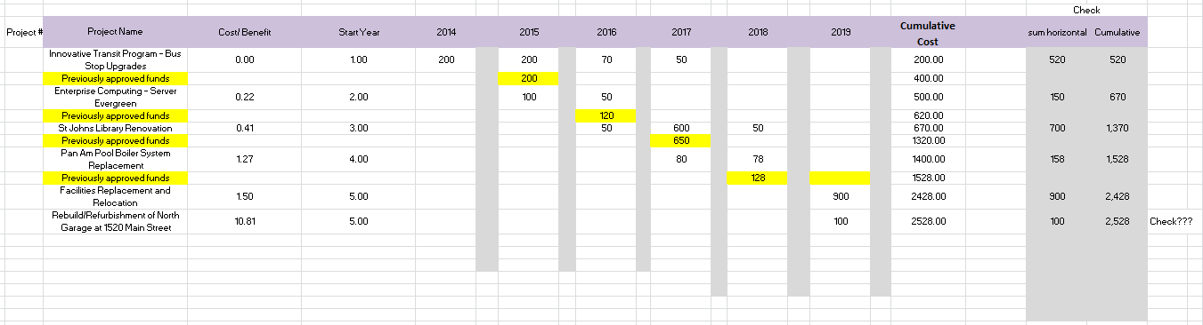
The Cumulative Cost chart data worksheet
- In the Cumulative Cost chart data worksheet:
  - Insert a line above each row that a project starts a new budget year.
  - Under the Project Name column, type: “Previously approved funds” in each of the rows.
The purpose of this row is to include an allowance for previous year budget funds.
  - If there are funds cash flowed for Projects approved in previous years:
In the “Previously approved funds” rows (the newly inserted rows created in Step 3b),
summarize the previous budget amounts.
  - In the Cumulative Cost column, add the cost for each year.
- On the Cumulative Capex Chart, edit the graph’s data based on the population:
- Edit ”Horizontal axis label should not be adjusted unless greater than 125 projects.

The Residual Risk Rating Matrix
The Residual Risk Rating Matrix (page 19) is used to evaluate Projects in terms of the relative urgency of performance issues and improvements by combining the Consequence and Likelihood of a failure.
A five-point rating scale ranging from VL to VH is used to rate the impact of the risk, where:
V = Very
L = Low
M = Medium
H = High
Consequence: What is the anticipated impact of failure on the public and the system if the investment is delayed? Establish one rating for each risk category, based on the worst / largest noted impact.
Likelihood: What is the anticipated timeline for loss or reduction of service
(i.e. when will the 'bad thing' happen if the investment is delayed)?

References and/or Resources
Title | Description | Document Location

Residual Risk Rating Matrix
Types of Impact |  | Consequence Ratings
Group | Measure | VL | L |  | M | H | VH
Economic | Financial Impact | <$100k | $100k-$500k |  | $500k-$1m | $1m-$10m | >$10m
Environmental | Environmental Impact | Managed incident with negligible impact on public amenity | Localized and short term effects on local ecosystem / amenity value / commerce |  | Widespread but short term effects on local ecosystem / amenity value / commerce | Widespread and long term effects on local ecosystem/ amenity value/ commerce. Likely to lead to prosecution and fines. | Widespread and persistent effects requiring specialist and extensive long term clean up and/or rehabilitation plan
Social | Damage to Reputation | Adverse Internal communications only - within own BU | Adverse corporate communications. Short term local media interest |  | Negative local media reports. Adverse contact from Regulators, Councilors etc. but manageable | Negative reports on national media. Significant adverse contact from Regulators, Councilors | Prolonged adverse local and national media coverage. Sustained criticism of organization by regulators and politicians
Legislative | Compliance with Existing Legislation | Minor breach. Adverse internal communications only within own Department. | Statutory body notification but no further action. Raised to senior management team and triggers investigation. |  | Statutory body notification with further external investigation. Criticism of organization with requirement for localized corrective actions | Statutory / regulatory instruction requiring fundamental change in strategic objectives or global management practices | Major breach. Potential for prosecution with severe fines and/or imprisonment. Potential revocation of regulatory license
Health and Safety | Safety | Minor injury(s) with no associated lost time | Reportable injury with lost time (typically < 3 days) |  | Significant injury requiring short term hospitalization | Serious injury or work related illness causing long term disability | Fatality of one or more people or long term disability affecting several people
Functional | Condition | Asset in "As New" condition | Asset in "Good" condition |  | Asset in "Fair" condition | Asset in "Poor" condition | Asset in "Failed" condition
 | CLOS | Minor CLOS deficiency in single area. | Minor CLOS deficiencies in multiple areas. |  | Moderate CLOS deficiencies in multiple areas. | Major CLOS deficiency in single area. | Major CLOS deficiencies in multiple areas.
Types of Impact |  | Likelihood Ratings
Group | Measure | VL | L | M |  | H | VH
Base Maintenance | Horizon | Likely to occur beyond 10 years | Likely to occur within 5 to 10 years | Likely to occur within 4 to 5 years |  | Likely to occur within 2 to 3 years | Occurred or occurrence imminent
 | Likelihood of occurrence | ≤5% | ≤10% | ≤25% |  | ≤50% | ≤100%

